Application / Nomination to become a member of the Board of Trustees
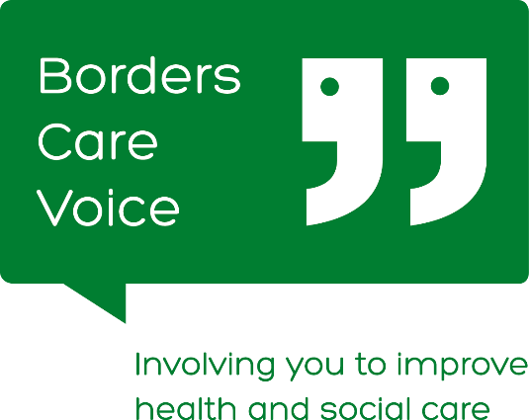

You must be a member of Borders Care Voice in order to stand for the Board of Trustees. You can sign up on our website at www.borderscarevoice.org.uk. Nominations for Trustees representing CORPORATE members (Companies, SCIOs and CICs) must have permission from one of their own Trustees or Directors. A copy of the Constitution is currently available by emailing: admin@borderscarevoice.org.uk.

Section 1: Name of person who wishes to join Board:
- If you are a current member of the Borders Care Voice Board of Trustees and are requesting re-election, please specify information:
- Number of months/years service: |  | Offices Held:
In order to stand for election or re-election at AGM you must be nominated by one other member of Borders Care Voice. Please complete their details here. If you have been invited to be co-opted through the year, you do not need a nomination.
Borders Care Voice Member Nominating you to join the Board: |  | Signature: |  | Date:
Your Correspondence Address & Postcode:
Telephone number:

Email address:

Dietary, Accessibility or Information requirements:
Medical Conditions and Emergency Contact Info:
- Section 2: (not required if seeking re-election)
- Please briefly explain why you think the work of Borders Care Voice is important to you.

Please briefly explain why you wish to join the Board of Trustees
Skills & Experience
Please see some examples below - Please tick boxes as appropriate.

Fundraising |  | Legal/HR
Project Management |  | IT/Systems
Business Planning |  | Change Management

Please detail these below and add any other skills and experience you could bring to the work of the Board.
Reference
All nominees must provide the name and contact details of a Referee who can vouch for your capabilities and conduct.

Name:

Address:

Telephone Number:

Email:

Section 3: Potential for Conflicts of Interest
If Trustees are closely involved with health and social care providers, including statutory services, we need to be aware of them. Board members must, where possible, place the interests of Borders Care Voice before their own organisations and must act in accordance with the Board’s Conflict of Interest Policy. Please list any roles you are involved in which might give rise to a conflict of interest and how you might manage these. If there are none please state this.

Declaration:
Borders Care Voice is a Scottish Charitable Incorporated Organisation. Legally some people cannot join the Board of Trustees and could face criminal charges if they did so. In general terms this includes:
- someone with an unspent conviction for dishonesty or an offence under the Charities and Trustee Investment (Scotland) Act 2005;
- an undischarged bankrupt;
- someone who has been removed under either Scottish or English Law or the courts from being a charity trustee; and / or
- a person disqualified from being a charity trustee
If you are not sure whether any of these apply to you please contact us. By signing below you confirm that you are not disbarred from being a Charity Trustee.

By signing this declaration you also agree to undergo a PVG Membership Application/Record Check for regulated work with adults and to complete a self-declaration form.
Signature of applicant to join Board: |  | Date:
Data Privacy: Any key information that is not confidential may be available to all members of Borders Care Voice prior to AGM so they can make an informed decision when electing members to the Board of Trustees. If elected this information will be held by Borders Care Voice staff in a central location and will not be passed onto any third parties. You can view our data privacy policy at

Please Sign and return this form to: admin@borderscarevoice.org.uk or post to Borders Care Voice, 3rd Floor, Triest House, Bridge Street, Galashiels, TD1 1SW.
For Office Use Only
Date received: | Accepted at AGM or Board (Date) | Self Dec. Complete  (Date) | PVG Form Given  (Date) | PVG Complete  (Date) | Initial When process complete

